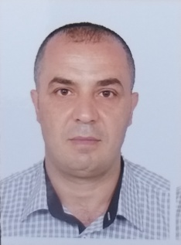
Curriculum Vitae
Personal Details:
Full Name: Chaker ABAS
Address: Lebanon, Tripoli, Nejmeh, Kanawati St., Sheikh bldg., 4th floor
Mobile number: +9613988122
E-mail: chaker_abas@hotmail.com

Education:
Certificate | Name of Institution | Year
High school | Al-Haddadine - Tripoli | 1990
B.A. in English Literature | Lebanese Uni. III Branch | 2000
M.A. in English Literature | Lebanese Uni. Deanship | 2017
Currently writing my PhD dissertation | Beirut Arab University | 2024-2025

Personal Experience:
Name of institute | Job | From | to | Total years
Beirut Arab University  (Tripoli Campus) | English instructor | Fall 2019-2020 | Fall 2024-2025 | 5
City University  (Tripoli Campus) | English instructor | Fall 2019-2020 | Fall 2022-2023 | 3
American University of Technology  (Akkar campus) | English instructor | Summer 2019-2020 | Fall 2020-2021 | 1

Qualification:
Date | Institution | Title
From 1st to 26th July 2019 | AMIDEAST & SIT World Learning (Vermont USA) | Professional Certificate of English Language Teaching (PCELT)
01-09-1997 to 01-01-2016 | General Directorate of State Security | Military

Languages: Arabic (native), English, and French.
Hobbies: Reading, swimming, Aikido, and jogging.

References:
 | Full Name | Email | Phone number
1 | Prof. Dr Muhammad Badawi | muhabad@hotmail.com | +9613932565
2 | Dr Lutfi Hamadeh | lutfihzj@hotmail.com | +96171332816
3 | Dr Samar Hamieh | samarhamieh@hotmail.com | +9613528385

