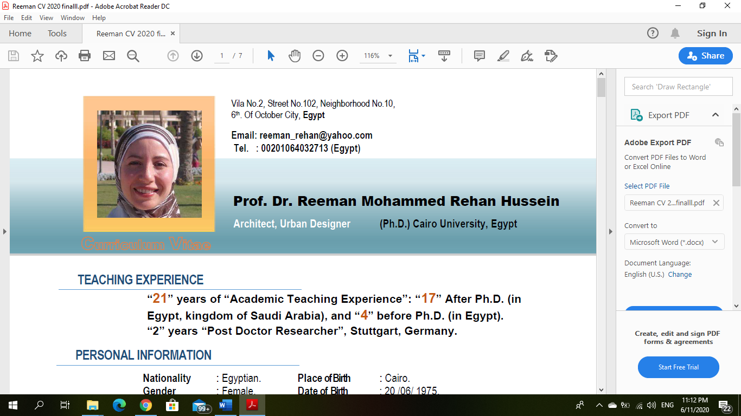


Prof. Dr. Ghada Mohammed Rehan Hussein

Architect, Urban Designer (Ph.D.) Cairo University, Egypt

Curriculum Vitae
Villa No.2, Street No.102, Neighborhood No.10,
6th. of October City, Egypt
Email: ghadarehan@yahoo.com
0096872285036
Tel.: 00201211945851 (Egypt)

6

TEACHING EXPERIENCE

“22” years of “Academic Teaching Experience”: “11” After Ph.D. (in Egypt, kingdom of Saudi Arabia), “6” (in Oman), and “5” before Ph.D. (in Egypt).
PERSONAL INFORMATION

Nationality : Egyptian Place of Birth : Giza
Gender : Female Date of Birth : 01/10/1976
Age : 43 Marital Status : Divorced

OCCUPATION

Professor: Helwan University, Faculty of Engineering, Department of Architecture, Egypt.

PERSONAL STATEMENT

A passionate professor and researcher with extensive teaching experience in higher education. Highly motivated, organised and efficient individual, whose commitment to research and teaching has yielded excellent results. Currently seeking a new challenge and position in academia with research interest in Architectural Design, Urban Design and Sustainable Urban Design.

KEY SKILLS

- Ability to teach in English and Arabic.
- Expertise in teaching theoretical and practical architecture and interior design courses.
- Excellent written and verbal communication skills.
- Excellent organisation and presentation skills.
- Ability to work individually and in a team.

EDUCATION

PhD, Architectural Engineering, Department of architecture, Faculty of Engineering, Cairo University, Egypt, 2003
(April 2001 – June 2003)
“New Economic Rules for New Urban Communities”

MSc, Architectural Engineering, Department of architecture, Faculty of Engineering, Cairo University, Egypt, 2001
(September 1999 – April 2001)
“Upgrading of Informal Areas”

Postgraduate studies, Department of Architecture, Faculty of Engineering, Cairo
University, (Oct. 1998 – July 1999). Grade: "Very Good"

BSc, Architectural Engineering, Department of architecture, Faculty of Engineering, Cairo University, Egypt, 1998
(September 1993 – September 1998)
- Graduation Year: “July 1998” - General Grade :Very Good
- Grade of B.Sc. Project: Excellent.

EMPLOYMENT HISTORY

- Nomination within 5 individuals to work for the position of cultural attaché in UNESCO.

Full Professor in Architectural Engineering, Department of Interior Design, Oman College for Management &Technology , Muscat, Saudi Oman.
(August 2023 – Till present)

Assistant Professor in Architectural Engineering, Department of Architectural Engineering and Interior Architecture, University of Dhofar, Oman
(February 2015 – June 2019)

Position: Associate Professor in Architectural Engineering and Interior Architecture Department.(2015-2019)

- Chair of University Scientific Research Committee.
- Chair of Eco Event Workshop for designing Eco Friendly House in Oman.
- Chair of Final Exams Committee.
- Chair of College Research Committee.

- Taught the following modules: Colour Fundamentals, Environmental Control System, Furniture Design, Finishes and Materials, Interior Architecture Studio, Drawing I, Drawing II, Modern Practice, Advanced Detailing and Community of Housing Design.
- Student career adviser.
- Supervision of final year projects.

Associate Professor in Architectural Engineering University of Modern Science and Arts (MSA), Faculty of Engineering, Egypt.
(September 2013 – Feb 2015)

- Taught architectural design courses, History of Architecture and Final year projects.

Associate Professor in Architectural Engineering, Department of Interior Design, king Abdulaziz University, Saudi Arabia
(September 2012 – July 2013)

- Taught the following modules: Residential and Commercial Building Design, Environmental Control System, History of Architecture, Conceptual History and Building and Finishing Materials.

Head of Architecture Department, Modern Academy, Maadi, Egypt
(September 2010 – July 2011)

- Taught architectural design courses, Final year projects..

Associate Professor in Architectural Engineering, Institute of Aviation Engineering and Technology, Egypt
(September 2007 – July 2010)

- Taught architectural design courses.

Lecturer in Architectural Engineering, October 6 University, Cairo, Egypt.
(September 2006 – July 2007)

- Taught architectural design courses.

Lecturer in Architectural Engineering, Higher Institute of Architectural Engineering, Cairo, Egypt.
(September 1998 – July 2000)

- Taught architectural design courses.

Lecturer in Architectural Engineering, October 6 University, Cairo, Egypt.
(September 1998 – July 1999)

- Taught design principles & architectural design and working drawing courses.

SCIENTIFIC CONSULTATION

- External Juror: University of Modern Science and Arts (MSA), Faculty of Engineering,
Department of Architecture. Student Project Jury Fall 2014/15, Egypt.
- External Juror: University of Dhofar, College of Engineering, member of the external jury
committee for the proposal of Interior Architecture design program,2016, Oman.
- Jury Member – Graduation Projects: Department of Architecture, Faculty of Engineering, Dhofar University, 2017-2019, Oman.
- Jury member: 4th Scientific Conference of the Higher Education in KSA,” ,2012, Ministry
of Higher Education, KSA.
- Academic advisor for postgraduate students: Department of Architecture, Faculty of
Engineering, Helwan University, 2009-2010. Egypt
- Urban Redevelopment of Egyptian cities: Organization Name: Urban Planning &
Development Authority, 2010-2011, Egypt.
- Supervisor of Postgraduate Students: Helwan University, 2002 till now, Egypt.

PROFFESIONAL PRACTICE

Consultant: Urban Redevelopment of Egyptian cities for Egypt Urban Planning & Development Authority
(September 2010 – September 2012)

Architectural Engineer, Private Practice, Cairo Egypt
(September 1998 – September 2012)

Residential Buildings

- Project design (architectural drawings) and coordination of a tourist village for a group of residential villas in Cairo.
Commercial Buildings

- Design of Tala Furniture Store, Jeddah, Saudi Arabia.
Educational Buildings

Redevelopment of an old factory in Almansora for the Higher Institute of Engineering in Sinbillawin.

PUBLICATIONS

PUBLISHED BOOKS
  - Upgrading of Informal Areas, Al-Ahram Publisher, Cairo, Egypt, 2008.

JOURNALS

  - Parks as Valuable Contributors to Green Infrastructure, Case study: the treating offsite Runoff at Hunter Point South Waterfront Park, Queens, New York, IJERST Journal ,2018
  - Architectural Renovation of Stadiums as a New Vision for Sustainability, Case Study (Renovation of Castelo Arena Stadium, Brazil &Soldier Field Stadium, Chicago), Architecture and Planning Journal, Faculty of Engineering, Beirut University, ISSN 2079-4096 ,26/6/2018.
  - Towards A New Vision for Sustainable Urban Parks - A Case Study of Alain Wildlife Park in Abu Dhabi, Cairo University Journal, 2012.
  - Greener greenbelt for more sustainable future case study of Vitoria gasteiz- Spain and ontario-canda, HBRC International Journal: Housing and Building National Research Centre. Production and hosting by Elsevier published 10 March 2014, HBRCJ-D-13-00072.
  - The impact of sustainability trends on housing design identity of Arab cities, HBRC International Journal: Housing and Building National Research Centre. Production and hosting by Elsevier. Http://ees.elsevier.com/hbrcj, Published: 27August 2012 Code: 349/AP41.

CONFERENCES

  - Urban Circular Economy as a Regenerative System for a Sustainable Future, IAPE 19 conference, international conference on innovative applied energy 2019, Oxford city, United Kingdom.
  - Spatial adaptability as a new approach for sustainable architectural design, DAKAM Conference, Greece, 2019.
  - Nomadic architecture – challenging and priority for repurposing buildings to achieve sustainability,2019, Turky.
  - Reuse, reduce and recycling materials as an approach for environmental sustainability, International conference on poverty and sustainable development- Colombo, Srilanka, http://povertyconferences.com/registration-form published 14-16 june2014.
  - Smart grid technology as a universal approach for an economical sustainable development, International conference on renewable energy and its future in the Arab world (ICREFAW), April 22-24, 2013.
  - Towards sustainable technological cities case study (new Sondo city, South Korea) , Art and architecture Journal, published by the Institute of Fine Arts at the Lebanese University, Beirut, Lebanon. November 14-16, 2012 ISSN: 1307-6892.
  - Towards a new vision for sustainable urban parks a case study of Alain wildlife park in Abu Dhabi, Ninth International Conference on Civil and Architecture Engineering - ICCAE-9. The Military Technical College, the Egyptian Ministry of Defence, Cairo, Egypt May 29-31, 2012.
  - Towards sustainable public squares competitive study between one of the most important squares in Egypt and Germany, Mimar Sinan fine arts university, faculty of architecture, Greenage II symposium, Istanbul, Turkey. April 26-27 /2012.
  - The Integration between transportation solution, economic development and community development as a new approach for sustainability case study (Curitiba – Brazil), World academy of science engineering and technology, DUBAI, UAE, http://waset.org/Publications?p=71, January 25 /2011.
  - Towards Sustainable Public Squares - A Comparative Study Between One of the Most Important Squares in Egypt and Germany, Greenage Symposium, Mimar Sinan Fine Arts University, Faculty of Architecture, Istanbul, Turkey, April, 2012.
  - The Thinking of Economic Clutters as One of the Basic Pillars to Build Self-Sufficient Urban Communities, Al-Azhar Engineering Eleventh International Conference, Cairo, Egypt. 21-23 December, 2010.
  - Towards Sustainable Technological Cities, Case Study (New Song Do City, South Korea), Conference of Sustainability, Military Technical College, May 2011.
  - Community and Cooperation Culture, the Conference on Sustainable Architectural and Urban Development, Cairo 24-26 February 2004.
  - Information Technology as A New Trend of Globalization with Special Request for Pyramid Smart Village in Cairo, Globalization and Beyond- Architecture, Communities and Setting, Cairo, 24-26 February, 2005.
  - Advantage Competitions as a Local Trend of Globalization, Globalization and Beyond- Architecture, Communities and Settings, Cairo 24-26 February 2005.
  - Future Vision for Developing the Central Commercial Axis-Case of “Elmalek Street”, Stuttgart, Germany, and Cairo May 2008.
  - People Participation as One of the Approaches for Future Development, Military Technical College- Cairo, Egypt, 27-29 May, 2008.
  - The Population Cooperation in The Vision of the Future City as The Basic of World Cities Success, Cairo, May 2008.
  - The Conceptual Follow between the Reality & the Supposed Case of “Phosfat Abu Tartur Elwadi Elgadid”, Cairo 24-26 February 2006.
  - Parks as Valuable Contributors to Green Infrastructure, Case study: the treating offsite Runoff at Hunter Point South Waterfront Park, Queens, New York.
https://www.linkedin.com/in/ghada-rehan-

PROFESSIONAL MEMBERSHIP

- Member of Alberta Association of Architects.
- Member of Association of Architecture Organizations.
- Member of Association of Licensed Architects.
- Cooperation with Greenwich University for upgrading informal areas in Italy.
- A reviewer of an Elsevier journal.
- A reviewer of “Materials Science Forum” journal, Scopus.
- A reviewer of Ain Shams Engineering Journal.
- Member of the Egyptian Architect Society.
- Member of the Egyptian Engineers Society.
- Member of the Egyptian Urban Planning Society.
- Community Service Committee, College of Engineering, MSA University, Egypt –2013.
- Scientific Research Committee, College of Engineering, MSA University Egypt –2013.
- Quality Research Assurance Committee, College of Engineering, MSA University, Egypt –2012- 2013

TRAINING COURSES

- University administration.
- Communication skills in different types of education.
- Examination systems and evaluation of students.
- Quality standards in the teaching process.
- Writing and dissemination of research internationally.
- Use of technology in teaching.

LANGUAES

Arabic: Mother tongue
English: Fluent (Speaking & Writing)
French: Good

HONORS AND AWARDS

- “Certificate of Appreciation”, University of Dhofar, KSA, 2019.
- “Certificate of Appreciation”, University of Dhofar, KSA, 2017.
- “Certificate of Appreciation”, Urban Planning & Development Authority, Egypt, 2014.
- “Academic Excellence Award” Cairo University, Egypt, 2002.
- “Award for Academic Excellence” Cairo University, Egypt, 2000.
- Best Architectural graduation projects, Egypt – 1998” Egyptian Architects Society – Cairo,
- - “Academic Excellence Award– Best graduation projects - 1997” – Cairo, Egypt,1997.
- - “Academic Excellence Award” (top 5%), Cairo University, Egypt, 1997.

REFERENCES

Prof.Yasser Mansour. Full professor, architectural department, Ain Shams University, Egypt.
  - Email: yassermansour@me.com
  - Mobile: 00201001380134

Prof.Medhat Dorra. Full professor, architectural department, Cairo University, Egypt.
  - Mobile: 00200122211909

Dr. Ahmed Faysal. assistant professor, architectural department, Dhofar University, Oman.
  - Email: ahmedfaysal@hotmail.com
  - Mobile: 0096891798123
  - Mobile: 0096897621007

