Nermine El Ahmad
Tripoli, Lebanon – (+961) 3 05 80 21 – Email
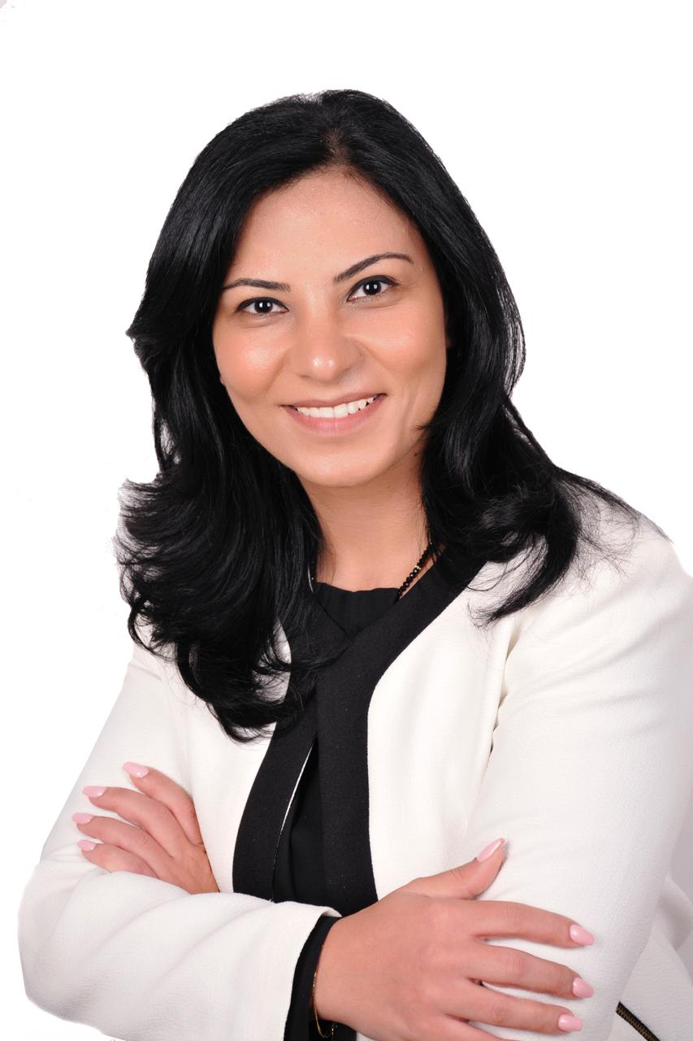
Profile | I am an active attorney at law since 2010, continuously seeking to expand my knowledge and apply it in service to others. Over the years, I’ve developed valuable skills that enhance my work. On a social level, my peers appreciate my hardworking and friendly personality
Experience | Trainer  Tripoli Bar Association  2024-PRESENT  Created and implemented extensive training programs tailored for legal professionals  Incorporated diverse teaching techniques and integrated technology such as e-learning platforms to accommodate different learning styles  Handled all logistical aspects of training programs to ensure seamless execution and participant satisfaction.  Conducted evaluations to gauge training effectiveness, incorporating feedback for continuous improvement  Collaborated closely with legal experts and organizations to enhance training content and invite guest speakers  Ensured that training programs adhered to accreditation standards and regulatory requirements, meticulously maintaining accurate participant records and certifications  PROJECT COORDINATOR  IMPLEMENTATION OF ARTICLE 47 PROJECT  HUMAN RIGHTS COMMITTEE – TRIPOLI BAR ASSOCIATION  2022-PRESENT  Creation of action plan and formulate effective strategies.  Developed and implemented strategies for sensitization, communication, and outreach involving the ISF, judges, attorneys, and key stakeholders  Facilitated round table discussions and training sessions for general prosecutors and investigative judges  COORDINATOR  EU4WE EUROPEAN UNION FOR WOMEN EMPOWERMENT  2022 – PRESENT  - Synchronized company operations.  - Assigned tasks to suitable team members.  - Managed internal and external communications.  - Ensured company objectives were met.  - Handled general administrative duties  LEGAL CONSULTANT  INTERSOS  2018 – PRESENT  - Advocated in Sharia and Civil Courts for various cases, such as but not limited to divorce, alimony, custody, and visitation.  - Advised and represented clients in court proceedings.  - Drafted, prepared, and filed legal documents, such as lawsuits, appeals, wills, contracts, and deeds.  - Followed up on cases to ensure progress and compliance.  Main Focus: Shari & Civil Courts, Personal Status  COMMITTEE MEMBER  SOCIAL COMMITTEE – TRIPOLI BAR ASSOCIATION  2014 - Present  - Conceptualized theme ideas and handled budget planning.  - Event Management:  - Organized and managed events.  - Coordinated with suppliers and liaised effectively.  - Presented post-event reports.  LEGAL CONSULTANT  UTOPIA  2019  - Advocated in Sharia and Civil Courts for various cases, such as but not limited to divorce, alimony, custody, and visitation.  - Advised and represented clients in court proceedings.  - Drafted, prepared, and filed legal documents, such as lawsuits, appeals, wills, contracts, and deeds.  - Followed up on cases to ensure progress and compliance  Main Focus: Shari & Civil Courts, Personal Status.  LEGAL OFFICER  BLUMONT  2013 – 2017  • Conduct Trainings, Counseling and Awareness Sessions for:  - Syrian Refugees  - Internal Security Forces  - Shari Court Judges  - Interns at the Tripoli Bar Association  - Non-Profit Organizations  • Legal Representations of Syrian Refugees in Courts.  • Regularization of the Legal Status of Syrian Refugees.  • Legal Training of Lebanese University students.  * Acting as Program Manager for two weeks:  - Editing final reports  - Supervising inventories and submission of deliverables.
Education | MASTER’S DEGREE IN BUSINESS LAW  ISLAMIC UNIVERSITY OF LEBANON  2020 - 2022  MASTER’S DEGREE IN CONTRACT LAW  LEBANESE UNIVERSITY – FACULTY OF LAW & POLITICAL SCIENCE  2019 - 2020  BACHELORE’S DEGREE IN LAW  LEBANESE UNIVERSITY – FACULTY OF LAW & POLITICAL SCIENCE  2008 – 2009
Certificates | 2022  THE INSTITUTE FOR HUMAN RIGHTS - TRIPOLI BAR ASSOCIATION  CERTIFICATE OF COMPLETING A TRAINING COURSE: THE ROLE OF ATTORNEYS IN AIDING STATELESS PEOPLE TO ACCESS JUSTICE  2021  INERTANTIONAL RESCUE COMMITTEE & TRIPOLI BAR ASSOCIATION  CERTIFICATE OF COMPLETING A TRAINING COURSE: CHILD TRAFFICKING  2021  INERTANTIONAL RESCUE COMMITTEE & TRIPOLI BAR ASSOCIATION  CERTIFICATE OF COMPLETING A TRAINING COURSE: CARING FOR CHILD SURVIVORS  2021  INERTANTIONAL RESCUE COMMITTEE & TRIPOLI BAR ASSOCIATION  CERTIFICATE OF PARTICIPATION IN THE PROFESSIONAL TRAINING SESSIONS ON CHILD FRIENDLY LEGAL AID  2021  EU4WE EUROPEAN UNION FOR WOMEN EMPOWERMENT & TRIPOLI BAR ASSOCIATION  CERTIFICATE OF COMPLETING A TRAINING COURSE: STRATEGIC LITIGATION  2021  LEBANESE CENTER FOR HUMAN RIGHTS & TRIPOLI BAR ASSOCIATION  CERTIFICATE OF COMPLETING A TRAINING COURSE: TRAINING OF TRAINERS  2016  DR. HABIB KHOURY,  CERTIFICATE OF COMPLETING A TRAINING COURSE: BODY LANGUAGE AND SALES  2013  CENTRE FOR EFFECTIVE DISPUTE RESOLUTION (CEDR)  ACCREDITATION TRAINING COURSE: MEDIATION
Skills | *PROBLEM SOLVING AND CRITICAL THINKING  *CONFLICT RESOLUTION AND MEDIATION  *NEGOTIATION  *ADAPTABILITY AND ABILITY TO MANAGE PRESSURE  *INFORMATION TECHNOLOGY:  - MICROSOFT OFFICE  - COMPUTER OPERATING SYSTEMS
Languages | Arabic: Native  English: Fluent  French: Fluent

